**Community Christian College**

**Student Survey Assessment**

**2023 Spring Course Evaluation Survey**

**Analysis and Assessment Report**

**December 20, 2023**

**Yuka S. Delkamp,**

**Acting Academic Dean / Business Process Consultant**

[**Yuka32@msn.com**](mailto:Yuka32@msn.com)

**615.668.8801**

**TABLE OF CONTENTS**

**BACKGROUND………………………………………………………………………….….…………….….3-5**

**SURVEY QUESTION ANALYSIS………….………………..….…………………………………….…5-9**

**PARTICIOATION ANALYSIS…………………………………………………………………………..9-11**

**EVALUATION SCORE OVERVIEW…………………………………………………………….…..12-16**

**SCORE BREAKDOWNS ON SUBJECT MATTERS………………………………………….…16-17**

**SCORE BREAKDOWNS ON SUBJECT MATTERS PER CLASS…………………….……..17-27**

**DEVIATIONS AND RISKS…………………………………………………………………………..…28-30**

**SWOT ANALYSIS………………………………………………………………………………….……..31-33**

**EXECUTIVE SUMMARY.……………………………………………………………………………….….34**

**RECOMMENDATIONS………………………………………………………………………………..35-39**

**NEXT STEPS?....................................................................................................40**

**APPENDIX………………………………………………………………………………….………….…..41-43**

**BACKGROUND**

**Business Need**

As part of the Continuous Performance Improvement Program of the Community Christian College (CCC), and in response to the recommendations made by TRACS (Transnational Association of Christian Colleges and Schools), comparative and quantified analyses of the various surveys, which includes but not limited to CCC’s Board of Trustees, Staff members, Graduated and current Students are needed for CCC’s assessment. This report contains the overview as well as quantitative and qualitative analyses of the surveys conducted in 2023 for the CCC’s Student Spring Course Evaluation Survey.

**Objectives**

This report provides overall and specific areas of analyses as assessments for satisfying the following objectives.

1. Provide CCC with the current data analysis and assessment that may be utilized and be helpful the Continuous Performance Improvement Program to move forward to the next stage of implementing corrective/improvement actions.
2. Provide CCC with the Course Evaluation Survey documents to assist in submitting to TRACS per its request.

**Scope**

Quantitative data analyses using the raw data of the CCC's Student Course Evaluation survey via the SurveyMonkey program. The analyses will only be based on the raw data provided, and cover the following areas as its scope:

* Quantitative analysis for the survey conducted in 2023
* Qualitative analysis for the survey conducted in 2023
* Executive Summary
* Recommendations

The following are NOT part of the scope for this report. Should those be included in the scope, further discussion for making an alignment with CCC will be required:

* Risk analysis or mitigation plan
* Corrective/improvement action implementation or execution of plans
* Control or maintenance plan
* Project management elements or components

**Strategic Approach Used For This Assessment and The Analyses**

In this Survey assessment and analysis, the following incremental and strategic approaches have been adopted to capture quantitative and qualitative aspects in data analysis and assessment. CCC Strategic Plan 2022 to 2026, which is a primary driving element of the performance improvement in this report, clearly states that CCC and Students will take the expected responsibilities to achieve the objectives (CCC Strategic Plan 2022 to 2026 page 5 and 6 under Institutional Responsibility for Meeting Objectives).This analysis approach enables to assess responsibilities of both CCC as a service provider and Students as service recipients to be benchmarked against the clause in the CCC Strategic Plan 2022 to 2026 and 2020-2021 Assessment Integration Plan.

The following shows the incremental steps taken in creating this analysis and assessment report.

1. How effectively survey questions were prepared and provided to CCC Students. This assessment depicts contents/structure of the survey question make-ups, invitations sent out to CCC Students as well as the efforts made for promoting Students’ participation in the survey.
2. How effectively CCC Students responded to the survey, scored the services (i.e. classes, communication, counseling, etc.) and products (i.e. course materials, objectives, assignments, etc.) provided by CCC. This assessment depicts responses per subject matter, question provided as well as class/section group.
3. Identify if there are gaps between the responses/scores returned and the expectations/objectives according to CCC Strategic Plan 2022 to 2026 as areas of opportunity. If discrepancies have been found, areas of opportunity such as whereabouts of discrepancies, and other factors that may affect the efficiencies and effectiveness of what CCC’s Strategic Plan 2022 to 2026 identified.
4. Based on the identified areas of opportunity, develop best practices to close the gaps as recommendations. The recommendations may include but not be limited to future improvement proposals with strategic, operational, financial and/or managerial elements that should help satisfy the expectations and goals stated in the CCC Policy and Strategy.

The following diagram shows the assessment approach based on the correlations between CCC as a service provider and Students as service/product recipients.



**Data Source Used**

[Welcome to SurveyMonkey!](https://www.surveymonkey.com/home/?ut_source=header)

**ANALYSIS SUMMARY**

1. **Survey Question Structure**

In the Spring Course Evaluation Survey, twenty-nine questions total were provided to Students. The following are two types of questions included in the survey.

* Twenty-one multiple-choice questions
* Eight binary (yes/no) questions

1. **Survey Question Makeups**
2. **Questions and Subject Matters**

The following are the 29 questions and its Subject Matters provided to the Students. The questions highlighted in **ORANGE** indicate binary questions.

* Q1: *How well did your instructor make clear what was expected in the course, i.e. syllabi, clear directions, etc.?* - Instructor
* Q2: *How well did the instructor help you understand the subject matter?* – Instructor
* Q3: *The instructor's classroom management allows discussion and questions to be answered.* - Instructor
* Q4: *How well did the instructor's assignments, projects, and class discussions encourage you to think critically for yourself?* - Instructor
* Q5: *How well did the instructor integrate course content with thoughtful understanding of the Christian faith?* - Instructor
* Q6: *How well did the assessment tools (test, papers, oral presentations) reflect important aspects of the course?* - Assessment Tools/System
* Q7: *Does the grading system used in this course accurately assess your achievement? -* Assessment Tools/System
* Q8: *The instructor makes himself/herself available for individual consultation.* – Instructor
* Q9: *Did the instructor use technology and/or education equipment (videos, computer, etc.) effectively in presenting the content materials for this course?* - Instructor
* Q10: *The resource materials chosen for this course (i.e. textbooks, class handouts, and educational learning aids) effectively helped the learning process.* - Course Materials
* Q11: *The instructor appears to have a grasp on the current issues within his/her field of research.* - Instructor
* Q12: *How well were the course objectives (as stated in the course syllabus) met?* - Objectives
* Q13: *What is the overall effectiveness of this instructor?* - Instructor
* Q14: *Did your mentor make any contact with you and your class by Announcements, updates, emails or phone calls?* – Mentor
* Q15: *The mentor makes himself/herself available for individual consultation.* – Mentor
* Q16*: How well did the mentor help you understand the subject matter?* – Mentor
* Q17: *The instructor was responsive when students had questions or needed assistance.* - Instructor
  + Q18: *The mentor explained concepts clearly.* - Mentor
  + Q19: *I was motivated to take responsibility for my own learning in this course. -* Motivation
  + Q20: *I was challenged to think deeply about the subject matter.* - Critical Thinking
  + Q21: *How satisfied were you with your own effort in this course?* – Own Effort
  + Q22: *I have put a great deal of effort into advancing my learning in this course.* - Own Effort
  + Q23: *In this course, I have been challenged to learn more than I expected.* - Critical Thinking
  + Q24: *The assigned readings helped me understand the course material.* - Course Materials
  + Q25: *I received useful feedback from the instructor.* - Instructor
  + Q26: *The instructor gave me constructive feedback on assignments.* – Instructor
  + Q27: *The course followed the syllabus.* - Course Materials
  + Q28: *Graded assignments helped me understand the course material.* - Course Materials
  + Q29: *I would highly recommend this course to other students.* – Recommendation

1. **Multiple – Choice vs. Binary Questions**

The following diagram shows the balance between multiple – choice questions and

binary questions included in the survey.

* Out of the 29 total questions, the vast majority (72.4%) are multiple – choices. The multiple – choice questions take the following scale for the assessment:
  + 5 – Extremely well/Strongly agree/Very satisfied
  + 4 – Somewhat well/Agree/Somewhat satisfied
  + 3 – Neutral/Neither satisfied nor dissatisfied
  + 2 - Somewhat not well/Disagree/Somewhat dissatisfied
  + 1 - Extremely not well/Strongly disagree/Very dissatisfied

1. **Subject Matters**

The following shows the ratio among the Subject Matters included in this survey.

* Out of the 29 questions, 41.4% are about Instructor’s performance followed by Course Materials (13.8%) and Mentor’s performance (13.8%). These three subject matters make up the great majority (69.0%) of the entire survey questions. The rest are almost equally divided among seven different subject matters.
* Although the rest of the Subject Matters are about products (Tools/System and Objectives) and process (Critical Thinking, and Motivation), those Subject Matters are related to the way their Instructors handled and managed his/her class.
* With those regards, this survey seems to be designed to focus mainly on assessing Instructors’ all-round performance levels.
* Questions concerning the library (“Assess the needs of the educational program and its emphasis electives and provide access to the appropriate level of research materials to graduate with an associate degree”) and facility (“Assess the needs and provide the appropriate facilities to support the educational and athletics requirements of the students”) which both are measurable components of the Objectives stated in the CCC Strategic Plan 2022 to 2026 (page 5 and 6) are not included in this survey.

1. **Subject Matters in Multiple - Choice Questions**

The following shows the Subject Matters included in the 21 multiple – choice questions in this survey:

* Out of the 21 multiple-choice questions, over half (59.1%) are the questions to assess the service providers’ (45.5% for Instructors and 13.6% for Mentors) levels of performance.
* The Subject Matters about products (Tools/System and Course Materials, 9.1% each) rank the third most frequently asked questions in the multiple – choice question category.

1. **Subject Matters in Binary (Yes/No) Questions:**

The following shows the Subject Matters included in the 8 binary questions in this

Survey:

* Contrasting to the makeups of the multiple – choice questions provided, over the third (37.5%) of the binary questions are about the Course Materials.
* The rest of the questions are equally divided among Mentors’ performance, Critical Thinking, and Students’ Own Effort (12.5% each).
* The response options are set up only for Yes or No, and no other options such as “neither or” or “I do not know” is given (hence binary).

1. **Participation**

There were 250 Students total that participated in this survey that were from 11 Classes and 21 Sections. According to the Director of Student Services, the number of entire enrolled CCC Students at the time of the survey was taken was 280. This accounts for 89.2% of the entire CCC Students participated in this Course Evaluation Survey. However, it is unclear if there were Students that may have participated multiple times in the survey or limited to a single participation per Student. Students were notified regarding the date, duration, and method of this survey three to four times in the fourth, eighth and twelfth week of the semester by their instructors as part of their assignment.

1. **Participants And Participation Rate**

Below is a breakdown of 250 Student counts and ratio per class participated in this survey:

* The top three classes (SPM, SOC and PED) take up the majority (68.0%) of the entire participation on this survey. CIS, MUS and REL show the least participation (1 Student each).

1. **Overall Question Response Rate**

The following graph shows the actual rate that Students responded to each question in this survey. The data highlighted in **LIGHT BLUE** represents binary (yes/no) questions:

* Overall, all the questions are responded with high and steady (lowest 95.8%; highest 97.6%) with minimal variance (median 96.7%).
* There is no significant difference in responses between multiple – choice (96.8%) and binary questions (96.5%).
* The following are the top questions with the highest response rate (97.6%):
  + Q1 (Instructor): *How well did your instructor make clear what was expected in the course, i.e. syllabi, clear directions, etc.?*
  + Q4 (Instructor): *How well did the instructor's assignments, projects, and class discussions encourage you to think critically for yourself?*
  + Q6 (Tools/System): *How well did the assessment tools (test, papers, oral presentations) reflect important aspects of the course?*
  + Q10 (Course Materials): *The resource materials chosen for this course (i.e. textbooks, class handouts, and educational learning aids) effectively helped the learning process.*
* The following are the bottom questions with the lowest response rate (95.6%).
  + Q3 (Instructor): *The instructor's classroom management allows discussion and questions to be answered.*
  + Q13 (Instructor): *What is the overall effectiveness of this instructor?*
  + Q19 (Motivation): *I was motivated to take responsibility for my own learning in this course.*
  + Q26 (Instructor): *The instructor gave me constructive feedback on assignments.*
  + Q28 (Course Materials): *Graded assignments helped me understand the course material.*

1. **Class - Section Response Rate**

The following graph shows the actual rate that Students per Class-Section responded to

this survey:

* Overall, a high percentage (97.6%) of the participants across the Classes and Sections responded with a few exceptions of ECE 102-1 (83.3%) and SOC 120-1 (88.9%).
* ECE 102-1 had the lowest response rate. Twelve Students participated in the survey. However, less than 10 Students responded to questions as an average.
* SOC 120-1, which is the section among one of the highest participated classes shows one of the lowest response rates. This class – section had 14 participants in total for this survey. This means it had an average of 12.4 Students responded.

1. **Evaluation Score Overview**
2. **Overall Scores** **For Multiple – Choice Questions**

The chart below shows the scores given to each multiple – choice question that CCC Students responded:

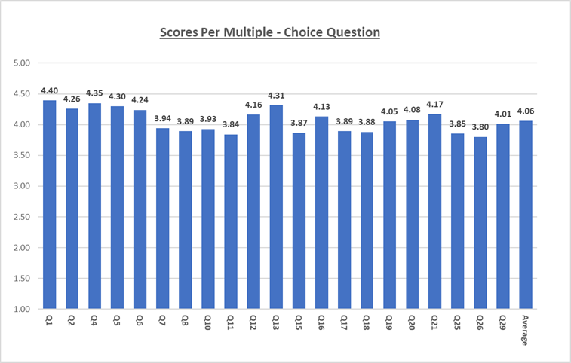

* Overall, CCC Students agree and are somewhat satisfied that their Instructors have given them clear expectations for the course. Students also agree that the assignments, projects and class discussions given by their instructors were effective, and somewhat encouraged themselves for their critical thinking as well as that their Instructors integrated course content with thoughtful understanding of the Christian faith and helped them understand the subject matter.
* CCC Students evaluated their Instructors neither gave them useful nor constructive feedback on their assignments. The Students are indifferent about their Instructors appear to have a grasp on the current issues within their field of research. They are also not agreeable or disagreeable to the availability of their Instructors and Mentors for individual consultation, or responsiveness of their Instructors when they had questions or when they needed assistance from their instructors.
* The lowest score among the multiple - choice questions was 3.80 (Q26: “*The instructor gave me constructive feedback on assignments.*”) and the highest was 4.40 (Q1: “*How well did your instructor make clear what was expected in the course, i.e. syllabi, clear directions, etc.?*” ) which the difference was 0.6 point.
* The following are the top 5 multiple – choice questions that scored the highest. These top scores fall in the low to mid ranges of 4’s:
  + Q1: *How well did your instructor make clear what was expected in the course, i.e. syllabi, clear directions, etc.?* – 4.40
  + Q4: *How well did the instructor's assignments, projects, and class discussions encourage you to think critically for yourself?* – 4.35
  + Q13: *What is the overall effectiveness of this instructor?* – 4.31
  + Q5: *How well did the instructor integrate course content with thoughtful understanding of the Christian faith?* – 4.30
  + Q2: *How well did the instructor help you understand the subject matter?* – 4.26
* The following are the bottom 5 multiple – choice questions that scored the lowest. These bottom scores fall in the high range of 3’s:
  + Q26: *The instructor gave me constructive feedback on assignments.* – 3.80
  + Q11*: The instructor appears to have a grasp on the current issues within his/her field of research.* - 3.84
  + Q25: *I received useful feedback from the instructor.* - 3.85
  + Q15: *The mentor makes himself/herself available for individual consultation.* - 3.88
  + Q8: *The instructor makes himself/herself available for individual consultation.* - 3.89
  + Q17: *The instructor was responsive when students had questions or needed assistance.* - 3.89

1. **Overall Scores For Binary Questions**

The chart below chart shows the scores to each binary question that CCC Students responded:

* As an average, 92.5% of Students responded favorably to the entire binary questions. The great majority responded favorably to the 8 binary questions. Q14 is the only binary question that is in the 80% range, and the rest is within the range of low to mid 90%. The difference between the highest (96.3%) and the lowest (80.0%) is 16.3%.
* The following are the top 3 binary questions that Students most responded favorably:
  + Q27: *The course followed the syllabus.* – 96.3%
  + Q3: *The instructor's classroom management allows discussion and questions to be answered.* – 95.9%
  + Q9: *Did the instructor use technology and/or education equipment (videos, computer, etc.) effectively in presenting the content materials for this course?* – 95.0%
* The following are the bottom binary question that Students least positively responded:
  + Q14: *Did your mentor make any contact with you and your class by Announcements, updates, emails or phone calls?* - 80.0%

1. **Correlations of Overall Scores: Class-Section, Responses And Participation in Multiple – Choice Questions**

The chart below shows how the average scores per class, the participation (count) and response rates (% of participants who responded to the provided 21 multiple - choice questions) are correlated.

The total number of Students at CCC at the time of the survey is 280, which 250 participated in the survey (89.2%). The breakdown of total number of Students per class is unknown, however.

* The following are the top 5 class - sections that scored the highest with its participation and response rates:
  + REL217-1 – Score 4.70 / 1 Student participated/100% responded
  + ECE 102-1 – Score 4.43 / 42 Students participated/83.3% responded
  + CIS 101-1 – Score 4.39 / 1 Student participated/100% responded
  + SOC 120-1 – Score 4.29 / 14 Students participated/88.9% responded
  + SOC 120-2 – Score 4.16 / 12 Students participated/99.7% responded
* The following are the bottom 5 class - sections that scored the lowest.
  + MUS 103-4 – Score 3.22 / 1 Student participated/100% responded
  + ESC 101-1 – Score 3.89 / 12 Students participated/97.7% responded
  + BUS 120-1 – Score 3.92 / 6 Students participated/99.4% responded
  + SPM 130-1 – Score 3.93 / 24 Students participated/95.5% responded
  + BUS 170-1 – Score 3.94 / 1 Student participated/100% responded
* The data shows that the scores are driven by two factors:
  + Number of participants: the fewer participants, the more weight on a participant influences the score.
  + Response rate: the fewer responses, the more weight on a response that influences the score.

1. **Correlations of Overall Scores: Class-Section, Responses And Participation in Binary (Yes/No) Questions**

The chart below shows how the participation (count), response rates (% of participants who responded to the provided 8 binary questions) and ratios between Yeses and Nos are correlated:

* The overall average for the binary questions is as follows:
  + Yes; 92.5%/No; 7.5%/Response rate; 95.8%/Participation counts; 11.9
* The following are the top 3 class - sections with its participation and response rates that responded most favorably:
  + BUS 105-1 - 100.0% favorable/Response rate; 100.0%/Participation counts; 5
  + MUS 103-1 - 100.0% favorable/Response rate; 100.0%/Participation counts; 1
  + SOC 120-2 –97.9% favorable/2.1% unfavorable/Response rate; 100.0%/Participation counts; 12
* The following are the bottom 3 class - sections that responded lowest to Yes:
  + HUM 101-3 –67.5% favorable/32.5% unfavorable/Response rate; 100.0%/Participation counts; 5
  + HUM 101-2 –83.3% favorable/16.7% unfavorable/Response rate; 100.0%/Participation counts; 3
  + SOC 120-4 - 85.3% favorable/14.7% unfavorable/Response rate; 100.0%/Participation counts; 17
* The data shows that the scores are driven by two factors:
  + Number of participants: the fewer participants, the more weight on each participant that influences the score. For example, there are 3 class-sections that had only 1 participant (CIS 101-1, MUS 103-1 and REL 217-1). This means the vote will only be either 0% or 100% with binary questions. On the other hand, for the class with the most participants (SPM 120-1; 43 participants), each participant’s vote weighs 2.3% against the whole, which causes significant difference in weight per vote.
  + Response rate: the fewer responses made, the more weight on each response that influences the score. This is a driving factor to accelerate the scores even more significantly with the participation factor.

1. **Score Breakdowns on Subject Matters**
2. **Overall**

**Overall Multiple – Choice Question Scores Per Subject Matter**

The chart below shows the average scores over 21 multiple-choice questions for each subject matter:

* Overall average is 4.06 (> 80.0 percentile).
* The following are the top 3 subject matters Students responded the highest: These top scores fall in the low ranges of the 4’s :
  + Students' own satisfaction to their efforts - 4.17
  + Objectives set - 4.16
  + Assessment Tools/Grading System - 4.09
* The following are the bottom 2 subject matters Students responded the lowest. These bottom scores fall in the high ranges of the 3’s:
  + Course recommendation to other students - 3.93
  + Mentor - 3.96
* Students indicated they would recommend the courses they took. However, this score barely made to 4’s.

1. **Overall Binary Question Scores Per Subject Matter**

The chart below shows the average scores over 8 yes/no questions for each subject matter:

* The overall average score that responded favorably is 92.5%.
* All subject matters are responded favorably (91.7% - 95.4%) except for Mentor (80.0% responded to yes).

1. **Score Breakdowns on Subject Matters Per Class-Section**
2. **Instructor’s Performance**

**Multiple – Choice Question Scores on Instructor’s Performance**

* This is the most frequently asked (10 out of 21 questions) subject matter among the entire multiple-choice questions. Overall, CCC Students rated somewhat satisfied (4.09) with their Instructor’s performance.
* The data, however indicates that there is a significant difference in scores (1.50 points; over one score rate) between the highest (4.70) and the lowest (3.20).
* REL 217-1 scored the highest (4.70) on this subject matter followed by CIS 101-1 (4.40), ECE 102-1 (4.39).
* On the other hand, MUS 103-1 (3.20), BUS 170-1 (3.86), and SPM 130-1 (3.93) scored the lowest that they neither agreed nor disagreed on this subject matter.

**Binary Question Scores on Instructor’s Performance**

* The average score for the 8 binary questions on Instructor’s performance is 90.4%.
* The following are the bottom 3 class-sections that responded the least favorably:
  + CIS 101-1 (Yes; 0.0%/No; 100.0%)
  + HUM 101-3 (Yes; 80.0%/No; 20.0%)
  + SOC 120-4 (Yes; 88.2%/No; 11.8%)
* The difference between the highest and lowest scores is 100 points. However, CIS 101-1 had only one participant/respondent to these questions.
* The data indicates that vast majority of CCC students agreed that the instructor's classroom management allowed discussion and questions were answered, and that their instructors use technology and/or education equipment effectively in presenting the content materials for their courses.
* Approximately 10.0% - 20.0% of Students from all HUM class-sections responded unfavorably to their Instructor’s performance.
* However low participation rates such as in REL217-1, CIS 101-1, and MUS 103-4 impact scores significantly particularly in binary questions.

1. **Course Materials**

**Multiple – Choice Question Scores on Course Materials**

* CCC Students scored as one of the lowest (3.93) in the course materials choices. However, there is only 0.07 point apart from promoting to 4’s.
* The data indicates that there is a significant difference between the highest (4.70) and the lowest (3.00) rated class-sections. The difference is 1.70 points which is almost 2 score ratings:
  + - * ECE 102-1, HUM 101-2, SOC 120-1 scored the highest (4.70, 4.20 and 4.15 respectfully) in this subject matter.
      * MUS 103-1, HUM 101-1 and ESC 101-2 scored the lowest (3.00, 3.60 and 3.73 respectfully) on the other hand.

**Binary Question Scores on Course Materials**

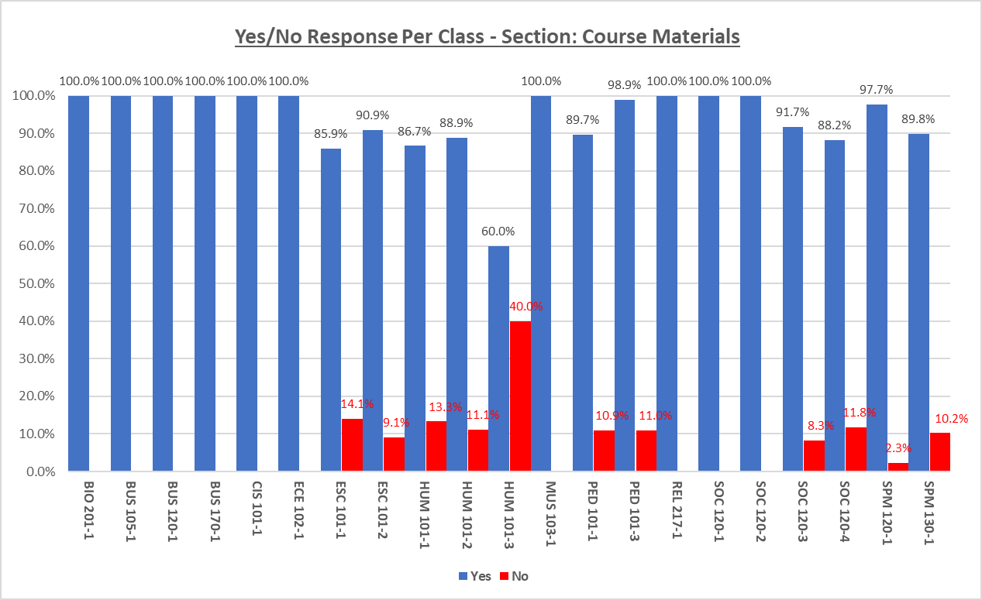

* Overall, almost half of the class-sections (10 out of 21 = 47.6%) responded favorably to all 3 questions (100.0%), and 1 class-section responded in high numbers to those questions (98.9% by PED 101-3; Q24 – 96.6%; Q27 and Q28 – 100.0%).
* The following are the bottom class-sections that responded to this subject matter of the binary questions:
  + HUM 101-3: Yes; 60.0%/No; 40.0%
  + ESC 101-1: Yes; 85.9%/No; 14.1%
  + HUM 101-1: Yes; 86.7%/No; 13.3%
* The difference between the highest and lowest is 40.0%. Unlike the results of the multiple-choice questions that the 3’s are dispersed throughout the class-sections, Students that responded less than favorable are of particular classes (ESCs, HUMs, and SOCs).

1. **Mentor**

**Multiple-Choice Question Scores on Mentor**

* Overall, CCC Students rated they are neutral (3.96) about their Mentor’s performance.
* The data, however indicates that there is a significant difference in scores (1.67 points; over one rating score) between the highest (4.67 with REL 217-1) and the lowest (3.00 with MUS 103-1).
* REL 217-1 (4.67) , ECE 102-1 (4.50) and HUM 101-2 (4.22) scored the highest that they rated somewhat well/satisfied with their Mentor’s performance.
* MUS 103-1 (3.00), HUM 101-1 (3.67), and BUS 120-1 (3.72) scored the lowest that they are neutral about their Mentor’s performance.
* Both REL 217-1 and MUS 103-1 had only one participant each, however.

**Binary Question Scores on Mentor**

* The average yes score of Mentor in the binary question is 77.4%. This is the lowest score among the entire subject matters in the binary questions.
* The following are the top 3 class-sections in this category.
  + BUS 105-1 (Yes; 100.0%)
  + CIS 101-1 (Yes; 100.0%)
  + MUS 103-1 (Yes; 100.0%)
* However, those class – sections had small numbers of participants (5 with BUS 105-1; 1 with CIS 101-1 and MUS 103-1 each).
* On the other hand, the following are the bottom 3 class-sections in this category.
  + REL 217-1 (Yes; 0.0%, No; 100.0%)
  + HUM 101-3 (Yes; 60.0%, No; 40.0%)
  + SPM 130-1 (Yes; 66.2%, No; 34.8%)
* The data indicates that three-quarters of the CCC students responded that their mentor made some contact with them and their class by announcements, updates, emails or phone calls while about one out of 4 responded otherwise. This is one of the lowest scores found in this survey.
* Overall, Students are neither satisfied nor dissatisfied with the Mentor’s performance through his/her availability, understanding of subject matter and/or explanation of contents explained clearly.

1. **Assignment Tools/System**

**Multiple-Choice Question Scores on Assignment Tools and System**

* Overall, CCC Students rated agreed (4.09) that the assessment tools (test, papers, oral presentations) reflect important aspects of the course, and the grading system used in this course accurately assesses their achievements.
* The data, however indicates that there is a significant difference in scores (2.00 points; 2 score ratings) between the highest (5.00) and the lowest (3.00).
* CIS 101-1 scored the highest (5.0: Strongly agree) while ECE 102-1 and REL 217-1 scored upper ranges of 4’s (4.65 and 4.50 respectively).
* On the other hand, MUS 103-1, HUM 101-2, ESC 101-2, BUS 105-1 and BIO 201-1 have rated neutral (3.00, 3.50, 3.79, 3.80, and 3.92 respectfully) with this subject matter.

**Binary Question Scores on Assignment Tools and System**

No binary questions provided for this subject matter.

1. **Critical Thinking**

**Multiple-Choice Question Scores On Critical Thinking**

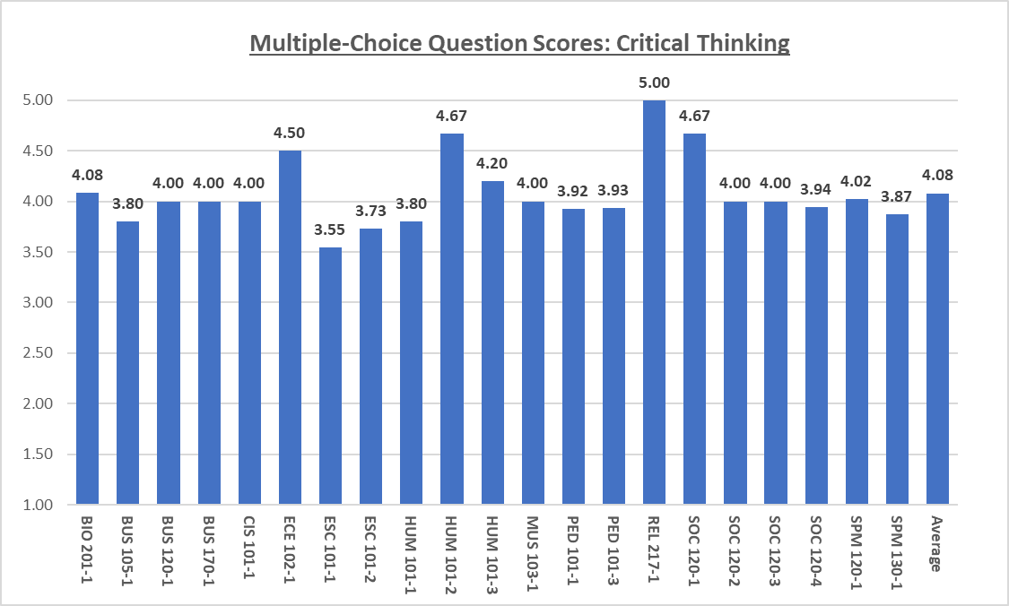

* Overall, CCC Students rated agreed (4.08) that they were challenged to think deeply about the subject matters they were learning.
* The data, however, indicates that there is a significant difference in scores (1.45 points; over one rating score) between the highest (5.00) and the lowest (3.55).
* REL 217-1 scored that they strongly agreed (5.0) to this subject matter followed by HUM 101-2 and SOC 120-1 (both 4.67) as well as ECE 102-1 (4.50).
* However, ESC 101-1 (3.55), ESC 101-2 (3.73), BUS 105-1 (3.80), and HUM 101-1 (3.80) scored the lowest that they neither agreed nor disagreed to this subject matter.

**Binary Question Scores On Critical Thinking**

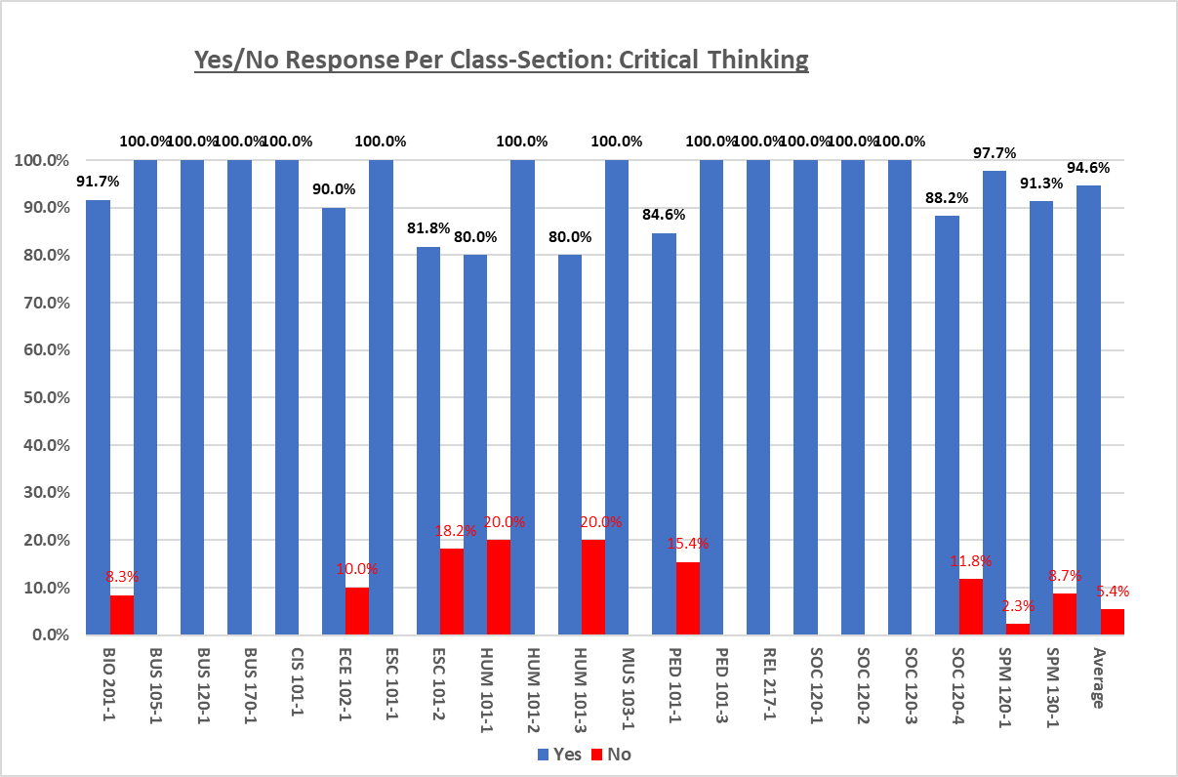

* The overall average score is one of the highest (94.6%) among the subject matters. However, this may be due to the fact that there is only one binary question provided for this subject matter.
* Twelve out of 21 class-sections responded favorably to this question (57.1%).
* The difference between the highest and lowest scores is 20 points. The highest and the lowest scores are from the same class (HUMs).
* The following are the bottom 3 class-sections that responded to yest the least.
  + HUM 101-1 (Yes; 80.0%/No; 20.0%)
  + HUM 101-3 (Yes; 80.0%/No; 20.0%)
  + ESC 101-2 (Yes; 81.8%/No; 18.2%)

1. **Own Effort**

**Multiple – Choice Question on Student’s Own Effort**

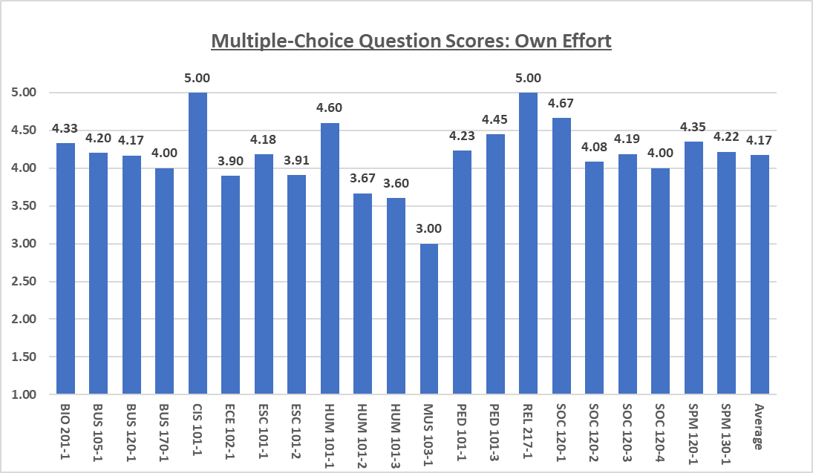

* CCC Students were somewhat satisfied (4.17) with their own effort in the courses they took. Out of the 21 class-sections that participated in this survey, 2 class-sections (9.5%) were very well satisfied with the effort they made while the 14 class-sections (66.7%) responded they were somewhat satisfied. This is one of the highest average scores among the entire subject matters.
* The data, however, indicates that there is a significant difference in scores (2.00 points; full 2 score ratings) between the highest (5.00) and the lowest (3.00).
* REL 217-1 and CIS 101-1 strongly agreed (5.00) to this subject matter followed by SOC 120-1 (4.67), HUM 101-1(4.60) and PED 101-1 (4.45) that they are somewhat satisfied with the effort they made for the courses.
* MUS 103-1 (3.00), HUM 101-3 (3.60), and HUM 101-2 (3.67) scored the lowest that they are neither satisfied nor dissatisfied with the effort they made.

**Binary Question Scores on Student’s Own Effort**

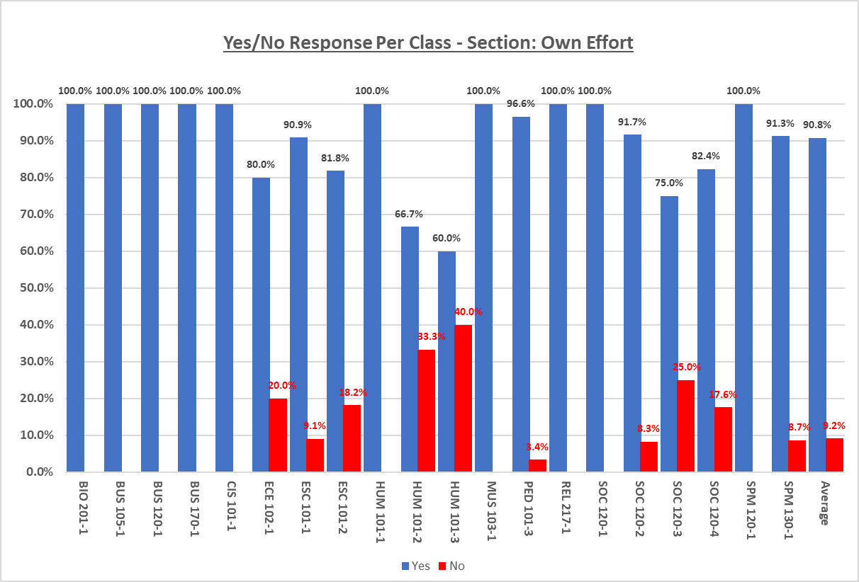

* The average score of Students’ own effort in the binary question is 90.8% favorable and 9.2% unfavorable.
* Ten out of 21 class – sections (47.6%) agreed in 100% that they put a great deal of effort into advancing their learning.
* No data is available for PED 101-1 with this question.
* However, 7 of those class – sections had small numbers of participants:
  + BUS 105-1; 5 participants
  + BUS 120-1; 6 participants
  + BUS 170-1; 6 participants
  + CIS 101-1; 1 participant
  + HUM 101-1; 5 participants
  + MUS 103-1; 1 participant
  + REL 217-1; 1 participant
* On the other hand, the following are the bottom 3 class-sections in this category.
  + HUM 101-3 (Yes; 60.0%, No; 40.0%)
  + HUM 101-2 (Yes; 66.7%, No; 33.3%)
  + SOC 120-4 (Yes; 75.0%, No; 25.0%)
* However, 2 of those class – sections had small numbers of participants.
  + HUM 101-3; 5 participants
  + HUM 101-2; 5 participants

1. **Motivation**

**Multiple-Choice** **Question Scores on Motivation**

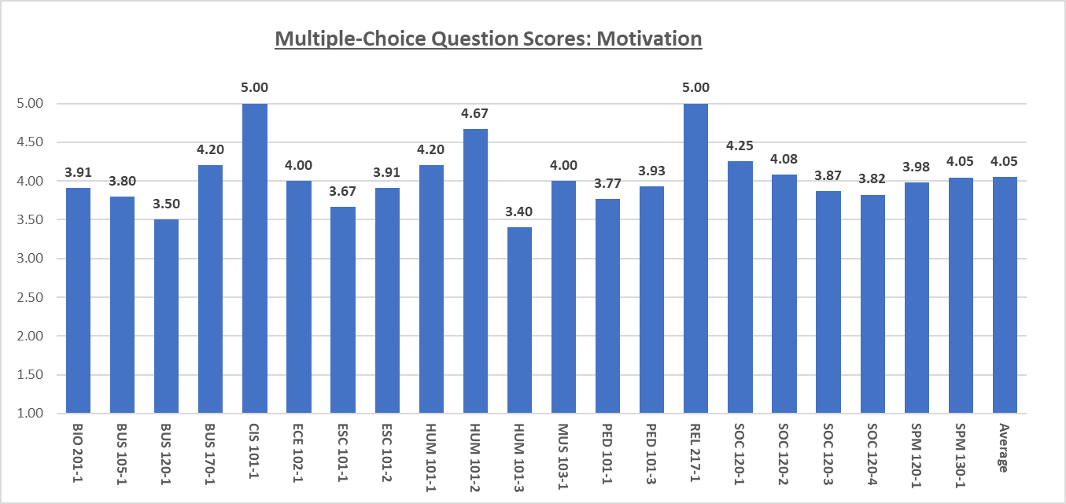

* Overall, CCC Students agreed (4.05) that they were motivated to take responsibility for their own learning in the courses.
* The data, however, indicates that there is a significant difference in scores (1.60 points; over one rating score) between the highest (5.00 with CIS 101-1 and REL 217-1) and the lowest (3.40 with HUM 101-3).
* REL 217-1 and CIS 101-1 are the strongest contenders, but they only had one participant each. HUM 101-2 (4.67) the next strongest contender had 3 participants.
* HUM 101-3 (3.40), BUS 120-1 (3.50) and ESC 101-1 (3.67) scored the lowest that they neither agree nor disagree that they were motivated to take their responsibility for their learning.

**Binary Question Scores on Motivation**

There is no binary question for this subject matter.

1. **Objectives**

**Multiple-Choice Questions Scores on Objectives**

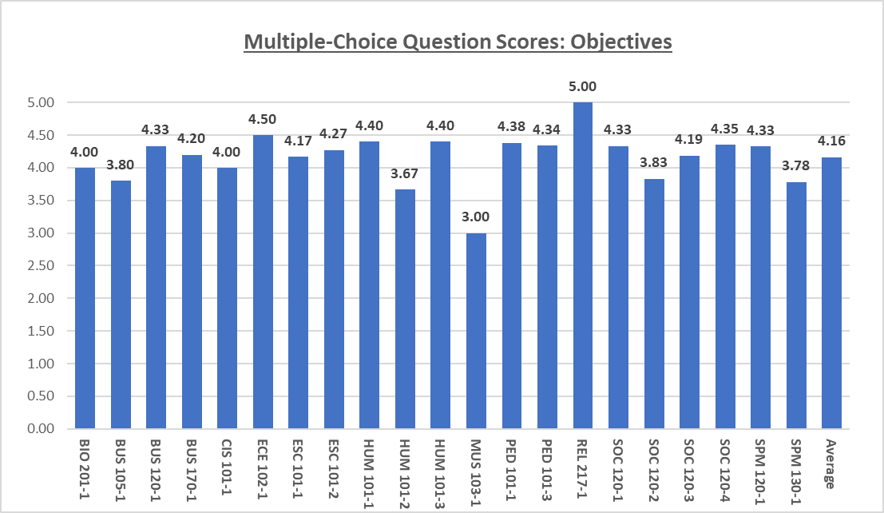

* Overall, CCC Students agreed (4.16) that their course objectives were met.
* The data, however indicates that there is a significant difference in scores (2.00 points full 2 score ratings) between the highest (5.00) and the lowest (3.00).
* REL 217-1 strongly agreed (5.00) to this subject matter followed by ECE 102-1 (4.50), HUM 101-1 and HUM 101-3 (both 4.40) that they agreed that their objectives were met.
* MUS 103-1 (3.00), HUM 101-2 (3.67), and SPM 130-1 (3.78) scored the lowest that they neither agree nor disagree.

**Binary question provided for this subject matter:**

There is no binary question for this subject matter.

1. **Recommendation**

**Multiple – Choice Questions Scores on Recommendation**

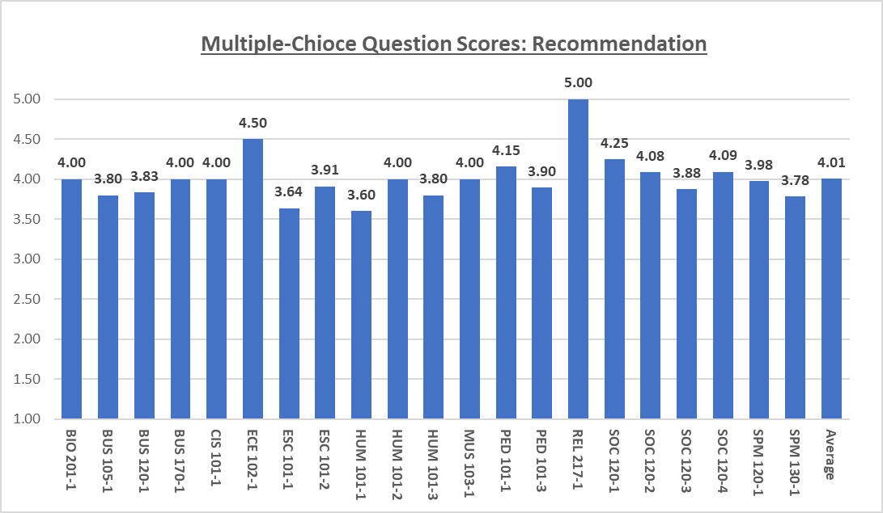

* CCC Students agreed (4.01) that they would strongly recommend the courses they took.
* The data, however, indicates that there is a significant difference in scores (1.40 points; over 1 score rating) between the highest (5.00) and the lowest (3.60).
* REL 217-1 strongly agreed (5.00) to this subject matter followed by ECE 102-1 (4.50).
* HUM 101-1 (3.60), ESC 101-2 (3.64) and SPM 130-1 (3.78) scored the lowest that the Students would neither recommend nor otherwise the courses they took.

**Binary question provided for this subject matter:**

There is no binary question for this subject matter.

1. **Deviations and Risks**
2. **Overall Deviations Among Multiple-Choice Questions**

Below diagram shows deviation of overall scores given in the multiple – choice questions against its average (4.06; See “Scores Per Multiple-Choice Question on page 16 in this report). This visualization represents population of Strengths, Weaknesses, Opportunities, and Threats which may help where should be focused on as the highest to the lowest priority for planning performance improvement activities. Each segment of elements is defined as follows:

* Strength: Scores greater than +20% above overall average. This segment should be maintained and controlled through future continuous improvement activities.
* Weakness: Scores greater than -20% below overall average. This segment depicts current risk. Intensive corrective actions should be expected.
* Opportunity 1: Scores up to negative (-) 10% below overall average. This is a segment that is a borderline and is close to being promoted into Opportunity 2, if enhanced but could be demoted to Threat, if no improvement activities are applied.
* Opportunity 2: Scores up to +10% above overall average. This is a segment that is a borderline and is close to being promoted into Opportunity 3 or even to strength, if enhanced but could be demoted to Opportunity 1 or Threat, if no improvement activities are applied.
* Opportunity 3: Scores between +10% ~+20% above overall average. This is a segment that is close to being included into Strength, if enhanced.
* Threat: Scores between negative (-)10% ~-20% below overall average. This segment needs to be paid much attention to assure not to slide to Weakness or becoming at risk.

* The diagram shows that the great majority (74.1%) of the entire scores are within the range of minus (-) 10.0% or less (opportunity 1) against the average score and within plus (+) 10.0% or less (opportunity 2) from the average score.
* The following are the smallest segments of score:
  + Over minus (-) 20.0% below the average (4.1%)
  + Over plus (+) 20.0% above the average (6.2%)
* The rest is almost equally split between over +10.0%/less than 20.0% above the average (Opportunity 3) and over -10.0%/less than -20.0% (Threat) below the average.

1. **Deviation Score Breakdown**

The following 2 diagrams show the breakdowns of how scores are deviated against the overall average.

**Subject Matters**

The chart below shows the breakdown of Strengths, Weaknesses, Opportunities and Threats as previously defined pertaining to each subject matter.

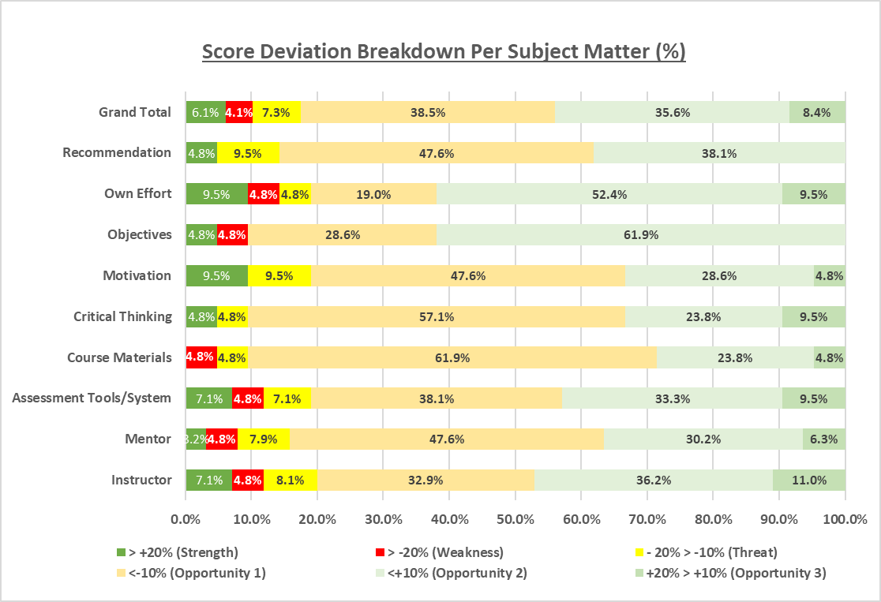

* The following are the top 3 subject matters with the highest rates of Opportunity 1 (up to -10% below overall average):
  + Course Materials (61.9%)
  + Critical Thinking (57.1%)
  + Mentor (47.6%)
  + Motivation (47.6%)
* The following are the top 3 subject matters with the highest rates of Opportunity 2 (up to +10% above overall average):
  + Objectives (61.9%)
  + Own Effort (52.4%)
  + Recommendation (38.1%)
* The following are the top 3 subject matters with the highest rates of Threat (between -10% ~20% below overall average):
  + Recommendation (9.5%)
  + Motivation (9.5%)
  + Instructor (8.1%)
* Six out of nine (66.6%) subject matters share the same rate (4.8%) of Weakness (greater than -20% below overall average). The following subject matters show no segment of Weakness.
  + Recommendation
  + Motivation
  + Critical Thinking

1. **Deviation Score Breakdowns – Classes**

The chart below shows the breakdown of Strengths, Weaknesses, Opportunities and Threats as previously defined pertaining to each class-section.

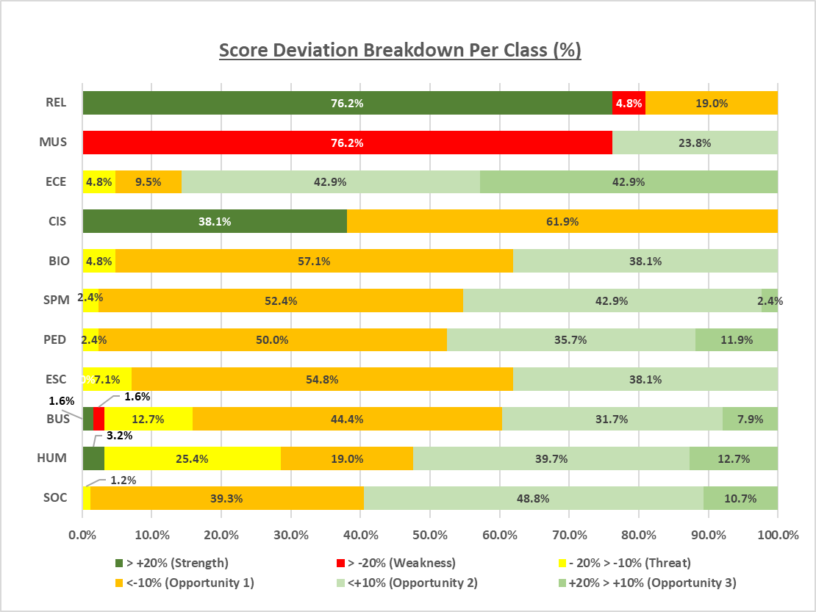

* The following are the top 3 subject matters with the highest rates of Opportunity 1 (up to -10% below overall average):
  + CIS (61.9%)
  + BIO (57.1%)
  + ESC (54.8%)
* The following are the top 3 subject matters with the highest rates of Opportunity 2 (up to +10% above overall average):
  + SOC (48.8%)
  + ECE (42.9%)
  + SPM (42.9%)
* The data of the REL class shows the vast majority (76.2%) falls onto a group that is greater than +20% against overall average (Strength), and the rest is split between Opportunity 1(19.0%), and Weakness (4.8%).
* The great majority (76.2%) of MUS class indicates as Weakness, and is a major contributor of the Weaknesses as a whole.

1. **SWOT Analysis**

The quantitative data analysis of survey scores with subject matters, classes, deviation against average and Student’s participation show various perspectives and characteristics. The charts below represent contributing elements (Strengths), immediate risks (Weaknesses), elements that can be converted to Strengths if improved (Opportunities) and elements that could turn to Weaknesses if no improvements are made (Threats). This tool can be useful for CCC to determine where improvements should be made and set up priorities for execution of improvement activities as planning the performance improvement.

1. **Subject Matter Scores**



* Overall data indicates that Course Materials and Mentor’s performance are the weaknesses which are the immediate concerns.
* The “Opportunities” has more subject matters than any other segments. The assumption is that if these subject matters have been improved, it may make a significant impact on the entire scores.
* Recommendations may be positively improved if the weaknesses and opportunities have been improved. If otherwise, further investigation may be required to discover what the root causes may be.

1. **Class Scores**



* In the class scores, the “Opportunities” also have more classes than any other segments. The assumption is that if these classes have been improved, it may make a significant impact to the entire scores.
* There is only a single source of class with Strengths, Weaknesses and Threats segment. However, this needs to be referenced against participation of each class. Some classes had only one or extremely small number of participants, which scores were driven drastically.

1. **Class and Subject Matter Combined Scores**



* Although REL is the significant leading factor that supports scores in Strengths, ECE is also a strong contender that strengthens four out of nine subject matters.
* On the other hand, even though MUS is the significant factor that weakens six out of nine subject matters, BIO (5 out of 9), ESC (4 out of 9), SPM and PED (Both 3 out of 9) are the major detractors that negatively impact overall scores as well.
* A variety of classes are supporting the scores across the nine subject matters for the opportunities which is the largest segment that can make a significant difference. In particular, SOC and BUS (5 out of 6 subject matters each) as well as CIS (4 out of nine) may have a strong impact on this segment.
* The segment “Threats” shows scores that are a mixture of 4’s and 3’s. HUM seem to be the vast majority (7 out of 3 subject matters) that supports this segment followed by SPM (6 out of 9). If those classes have been improved and moved to Opportunities, the entire score may be improved as well. This no improvements are made, this also may turn to Weaknesses, which is a risk.

1. **Participation**



* As previously mentioned, REL, the strong contender of the score, is an element of weaknesses in participation. This means that the small number of participants, one student to be exact, carries 100% of the vote. The same is also true for CIS and MUS.
* SOC had a good size as sample population (59 Students) and carries an impact over 5 out of 9 subject matters as previously mentioned. SPM also had a significant sample size (67 Students) of which currently the score is split between Weaknesses and various Opportunities across 6 out of 9 subject matters. On the other hand, PED represents a fair amount of the Students’ voices (44 Students), meaning 3 out of 9 subject matters are showing 3’s that resulted in part of the weaknesses in score. This also applies that ESC (24 Students) is part of the elements that are causing weaknesses in 4 subject matters.

**Executive Summary**

**What Story Does The Data Tell?**

The result of the survey shows that the Students of CCC evaluated over 80.0% in favor; they are somewhat satisfied with Instructor’s performance, assessment tools and system used for grading Student’s performance, critical thinking they learned through their courses, and motivation they received. Most of them evaluated that the objectives set were met, and somewhat satisfied with the level of effort they had put into their courses. This is a significant (and encouraging) result not only to CCC Students but to the staff, faculty, and administration on the CCC’s service offerings.

On the other hand, CCC Students show that they are indifferent about Course Materials used for the classes and Mentor’s performance. These were particularly shown among BIO, BUS, ESC, MUS, PED, SOC, SPM as well as HUM and CIS classes. However, CIS, MUS and REL had one participant each, which could be lack of sufficient data sample. Therefore, the results that came out from those classes may not be an accurate representation of collective voices of the classes as a whole.

With that participation factor in mind, the data indicates that about 1 out of 4 students responded less than favorable that their Mentor did not make contact with them and their class by announcements, updates, emails or phone calls.

As for the Course Materials, unfavorable votes came from certain classes, (ESCs, HUMs and SPMs in particular) but overall Students responded from high 3’s to low 4’s.

Students overall agreed that they would strongly recommend courses they took. This result clearly reflects scores on each subject matter. The class-sections that scored steadily in favor across the subject matters such as CIS 101-1, ECE 102-1, REL 217-1 and SOCs responded favorably to highly recommend their classes. Meanwhile those class – sections that scored in 3’s overall such as ESCs and HUM 101-1 also have scored 3’s for Recommendation. The only exception to this is MUS 103-1. The MUS 103-1 class-section scored low to high 3’s in the vast majority of the subject matters, yet agreed to strongly recommend the courses he/she took. This could be due to the lack of enough data samples from this group. Hence, the number of participants and score of each subject matter could be a critical driving factor to raise the Recommendation score. As each subject matter score improves, the Recommendation score should also be improved as a result.

The classes with the vast numbers of participants such as SPM, SOC and PED are the major contributors of Opportunities and Threats. Improving the scores of those classes with a steady pace of participants from Threats to Opportunities to Strengths may be a powerful driving factor to move a needle from the current overall average of 4.06 to the next level.

The combination of Weaknesses and Threats are the current risks, and those risks are detected across the subject matters. The good news is that the overall number of such risks is not as significant as Opportunities 1 to 3. Working on the various levels of Opportunities seem to hold the crucial key to separate 3’s (neither nor) from 4’s (agree/somewhat satisfied/somewhat well) and 4’s from achieving 5’s (strongly agree/strongly satisfied).

**Recommendations**

**Transform From Good To Great**

As part of the CCC’s performance improvement program based on the results of this Course Evaluation Survey in participation rates, scores on subject matter and scores given by class and class sections, the following strategic and operational approach is highly recommended.

1. **Target Setting**

It is critical for CCC administration and the Board to determine whether the current average 4.06 is sufficient or needs to be aimed higher. This decision drives not only the methodology and approach but the velocity of execution of improvement activities. If CCC decides to aim higher, the decision-making entity also should determine the quantified target for benchmarking. Such determination also should adopt a strategic method and not based on perception. The “S.M.A.R.T.” method below could be one of such strategic methods.

* 1. Specific
  2. Measurable
  3. Achievable
  4. Realistic
  5. Time-driven

1. **Transformational Approach**

This recommendation is based on the assumption that CCC has decided to pursue further improvement from 4.06 to a higher score.

As the previous SWOT diagrams and the findings show, an incremental but solid approach is required. The following are the steps of the incremental approach:

* 1. Move the needle from Weaknesses to Threats and/or Opportunities.
  2. Move the needle from Threats to Opportunities.
  3. Move the needle from Opportunities to Strengths.
  4. Control and Standardize the results of Strengths.

1. **Operational Steps in Preparing Plans for Improvement Activities**

See each SWOT segment of the following SWOT analysis diagram. Build a step-by-step execution plan for the operational improvement to incrementally transform from Weaknesses to Threats to Opportunities and to Strengths as the blue arrows indicate the directions of such incremental improvement process.



**Examples of Building Execution Plans**

**Example 1: Transform Mentor’s Performance from Weaknesses to Threats/Opportunities**

* **Step 1.** Form a diverse focus group (BIO, ESC, MUS, PED, SPM, HUM. SOC, BUS and CIS classes in particular), and collect their feedback in detail on the following. This should be facilitated by someone that is neutral, objective, and qualified in a safe environment so that Students will not feel obligated to provide preconceived or biased feedback. This can be done in-person or virtual settings. Thorough documentation is essential:
  + Mentor’s availability for individual consultation
  + Process of consultation
  + What/when/how Students want for consultation
  + Hits and misses of current consultation by Mentor and in mentorship
  + Priority in Student’s expectation for Mentors and mentorship; highest to lowest
  + Any suggestions and/or requests for Mentor and mentorship
* **Step 2**. Organize and categorize the feedback collected from the Students in the order of the most to the least focusing on the below subjects:
  + Process (before/during/after consultation was or was not conducted)
  + Product (anything tangible or intangible came out or used before/during/after for mentorship)
  + Personnel (anything about Mentor and mentorship. Mentor’s individual name should never be mentioned in the document)
  + Safety/security issues
  + Any suggestions and/or requests for Mentor and mentorship
* **Step 3.** Validate the organized and categorized data against the survey data analysis in this and past documents, **current** process, procedures, and expectation that are assigned to Mentors by CCC. Focus on the below process instead of the individual mentors. This can also be done by interviewing Mentors:
  + End-to-end process of mentorship
  + Materials currently used by Mentors
  + Awareness in assigned responsibility among Mentors
  + Any suggestions and/or requests by Mentors
* **Step 4.** Analyze gaps among the survey data analysis, Student focus group feedback, **current** process/procedures, and Mentors’ understanding. Assess severity, seriousness, and complexity of gaps in a quantitative manner.
* **Step 5.** Share the gaps with CCC’s decision making groups and discuss possible root causes and set the priority. Build mitigation plans to eliminate the identified root causes. Be sure to include the following items in the mitigation plans:
  + Scope and expectation
  + Quantified target and duration
  + Action items and timelines
  + Assignees
  + Resources
  + Method of verification (completion of action items) and validation (effectiveness of action items)
* **Step 6.** Track the actual progress and validate the effectiveness against the target.
* **Step 7.** Make an assessment during the execution, and necessary adjustments if not meeting expectation.
* **Step 8.** Report updates to the stakeholders.
* **Step 9.** Create Lessons Learned with narratives and process to be used for other areas as a point of reference.
* **Step 10.** Build a control plan by developing standardized tracking process, KPIs, RACI chart, and risk management process and documents. Procedurize, share among stakeholders and operationalize the control plan as part of the CCC Strategy and Policy.

**Example 2: Transform Instructor’s Performance, Critical Thinking and Motivation from Opportunities to Strengths.**

* **Step 1.** Verify the **current actual** process and practice as well as the level of understanding among Instructors in the following areas. Focus on the process instead of the individuals that are involved (never mention Instructors or faculty’s names). This can also be done by interviewing Instructors and other resources:
  + Setting expectations
  + Extending help to Students
  + Classroom management
  + Correlations between providing assignments/projects/class discussions to develop critical thinking among Students
  + Course contents with thoughtful understanding of the Christian faith
  + Availability and responsiveness of Instructors for consultation, questions, and assistance
  + Use of technology and presentation skills using the technology
  + Keeping up with the current issues related to their fields of research
  + Giving motivations to take responsibility for Students learning
  + Challenging Students’ deep-thinking process
  + Providing useful and constructive feedback to Students
* **Step 2**. Create a **current** process map based on the above findings that depicts communication flow, business requirements, process inputs, activities, and outputs in the sequential order. Using the process map, identify where the deficiencies against the survey data analysis in this and past documents, current process, procedures, and expectation that are assigned to Instructors by CCC and variables are coming from.
* **Step 3.** Analyze gaps among the survey data analysis, Student focus group feedback, current process/procedures and Instructors’ understanding. Assess severity, seriousness, and complexity of gaps in a quantitative manner.
* **Step 4.** Share the gaps with CCC’s decision making groups and discuss possible root causes and set the priority. Build mitigation plans to eliminate the identified root causes. Be sure to include the following items in the mitigation plans:
  + Scope and expectation
  + Quantified target and duration
  + Action items and timelines
  + Assignees
  + Resources
  + Method of verification (completion of action items) and validation (effectiveness of action items)
* **Step 5.** Track the actual progress and validate the effectiveness against the target.
* **Step 6.** Make an assessment during the execution, and make necessary adjustments if not meeting expectation.
* **Step 7.** Report updates to the stakeholders.
* **Step 8.** Create Lessons Learned with narratives and process to be used for other areas as a point of reference.
* **Step 9.** Build a control plan by developing standardized tracking processes, KPI, RACI chart, and risk management process.

1. **Streamline Structure of Questions**

Survey is a very effective method of collecting data from a direct source of interest. In developing appropriate and effective survey questions, CCC should build a process to identify the logic behind the weight between multiple – choice and binary questions. The logic and weight should be tracked and measured against goals and objectives.

If there is no specific logic to have yes/no questions to scale against the goals and objectives, replace them with open-ended questions for multiple – choice questions or questions to promote Students’ feedback by adding options that Students can leave their feedback and suggestions for improvement. This will not only help elaborate on qualitative data analysis to support the quantitative analysis but may reduce the time and effort to spend for forming the abovementioned focus groups. Furthermore, qualitative analysis with more voice of Students will help validate (or otherwise contradict) the quantitative data analysis from the survey results as well as identify low-hanging fruit for quick wins in setting priority as planning improvement strategy.

It is also highly recommended that CCC should numerically and metrically weigh the importance of subject matters, and carefully reflect the importance into the survey questions. For example, if the Instructor’s performance, Course Materials and Mentor’s performance are equally important and that the critical data needs to be collected for, the volume of questions should be balanced out equally as a whole. On the other hand, if CCC is interested in the level of Instructors and Mentors’ performance, the survey questions should reflect the weight of importance.

Apart from the weight and distribution of questions, below are a few points that could improve in developing effective survey questions in the future.

* Avoid duplicated or confusing questions (i.e., Q25 and 26. See Survey Question Makeups on page 5 in this document).
* Develop questions to better fit the form and style to meet the objective; form open-ended questions for multiple choice/rating questions and close-ended (yes/no) questions for binary questions.

Example:

* + The Q7 (*Does the grading system used in this course accurately assess your achievement?* ) is a close-ended question. This should be a binary question instead of a multiple-choice question. If this needs to be part of the multiple – choice questions, it should be rearranged to better fit as an open-ended question or a statement for rating.
* Organize the questions in the order of the same group; group each subject matter in the same section instead of in a random order of sequence so that the participants may not get confused.
* The CCC Strategic Plan 2022 to 2026 states utilization of library, facilities and technology (e.g. Chapter 2 Misson Statement and Objectives on page 6 and Chapter 8 The Strategic Plan). There was only one technology-related question but, no questions referring to utilization of virtual or otherwise library and facilities. CCC may want to validate the importance of those subject matters to consider to include in the survey.

1. **Enhancing Participation**

Promote active participation in the survey and measure as part of the CCC’s performance indicators. Having an extremely small number of participants could result in a skewed conclusion. It may be beneficial if CCC makes survey participation mandatory for Students. The following are the critical areas to focus on to increase participation. This impacts especially binary questions.

* Increase the number of participants per Class-Section level.
* If this is not an option, increase the number of participants per Class level.

**Next Steps?**

Before utilizing the strategy and methodology stated in Recommendations above, develop an immediate as well as the executable plan to solidify the operational foundation as shown below. This preparation should give CCC a jump start to a successful transformation journey.

1. Build a visual and comprehensive scorecard that shows the year-over-year progress that includes but not limited to Summer and Fall Surveys, Course Evaluation Surveys, Staff Surveys and Board of Trustee Surveys.
2. Share the current traits, patterns, analyses and findings with relevant decision-making bodies such as Board members and Administration.
3. Based on the Recommendations stated in this document and the CCC Strategic Plan 2022 to 2026, prioritize what areas to be focused on. The tool below should be helpful in setting priorities.



The characteristics of each segment:

* Do first: High complexity with high returns of business value. This is a major project with a strategic plan and incremental steps (as previously stated) are required.
* Do second: Low complexity with high returns of business value. Operational execution may be the major focal point.
* Do last: Low complexity with low returns of business value. If time, resources and funds are available, this should be worked on after the first 2 have been successfully executed and returns are realized.
* Avoid: High complexity with low returns of business value. This will be waste of time, effort, resources and funds.
* All segments are time-driven, and need to be defined, tracked and measured.

**APPENDIX**

**CCC Strategic Plan 2022 to 2026 page 5 and 6:**

**Institutional Responsibility for Meeting Objectives:**

All functions of cCc’s organization relates directly to the objective needed to be achieved by the students upon graduation. To that end, each department will take the following responsibility:

1. Administration: Serves to enable success by hiring qualified personnel using diverse committees trained in equity, diversity, and inclusion, promoting appropriate job training and continuing education, and ensuring the accomplishment of the objective.
2. Admissions: To admit students who are seeking an opportunity to increase their grade point averages in an effort to attend a four-year college and graduate.
3. Student Services: Demonstrate equity, diversity, and inclusion in the administration of the student government and while engaging in providing students with extra-curricular activities.
4. Education: Provide students with a Christian Worldview through-out the curricula, provide Chapel opportunities to all students, local and remote, develop within the students:
   1. Appropriate associate degree level reasoning skills allowing for success at a four-year college
   2. Appropriate associate degree level writing skills allowing for success at a four-year college
   3. Appropriate associate degree level research skills allowing for success at a four-year college
5. Faculty: To develop course materials that adequately reflects the objectives of the institution, to continue to develop a personal level of skill within their field of study, and to be well-versed in equity, diversity, and inclusion.
6. Library: Assess the needs of the educational program and its emphasis electives and provide access to the appropriate level of research materials to graduate with an associate degree.
7. Facilities: Assess the needs and provide the appropriate facilities to support the educational and athletics requirements of the students
8. Fundraising: Seeks to provide the financial resources necessary to support the educational and athletic program objectives.
9. Students: Students should provide their reasonable best efforts to support the institutional objectives, display equity, diversity, and inclusion in all they do, and to make themselves available to the all the opportunities made available by cCc.

**Multiple – choice questions** **provided on Instructor’s performance:**

Q1: *How well did your instructor make clear what was expected in the course, i.e. syllabi, clear directions, etc.?*

Q2: *How well did the instructor help you understand the subject matter?*

Q4: *How well did the instructor's assignments, projects, and class discussions encourage you to think critically for yourself?*

Q5: *How well did the instructor integrate course content with thoughtful understanding of the Christian faith?*

Q8: *The instructor makes himself/herself available for individual consultation.*

Q11: *The instructor appears to have a grasp on the current issues within his/her field of research.*

Q13: *What is the overall effectiveness of this instructor?*

Q17: *The instructor was responsive when students had questions or needed assistance.*

Q25: *I received useful feedback from the instructor.*

Q26: *The instructor gave me constructive feedback on assignments.*

**Binary Questions provided on Instructor’s Performance**

Q3: *The instructor's classroom management allows discussion and questions to be answered.*

Q9: *Did the instructor use technology and/or education equipment (videos, computer, etc.) effectively in presenting the content materials for this course?*

**Multiple – Choice Questions provided on Course Materials**

Q10: *The resource materials chosen for this course (i.e. textbooks, class handouts, and educational learning aids) effectively helped the learning process.*

**Binary Questions provided on Course Materials**

Q24: *The assigned readings helped me understand the course material.*

Q27: *The course followed the syllabus.*

Q28: *Graded assignments helped me understand the course material.*

**Multiple-choice questions provided on Mentor**

Q15: *The mentor makes himself/herself available for individual consultation.*

Q16: *How well did the mentor help you understand the subject matter?*

Q18: *The mentor explained concepts clearly.*

**Binary questions provided on Mentor**

Q14: *Did your mentor make any contact with you and your class by Announcements, updates, emails or phone calls?*

**Multiple-choice questions provided on Assignment Tools and System**

*Q6: How well did the assessment tools (test, papers, oral presentations) reflect important aspects of the course?*

*Q7: Does the grading system used in this course accurately assess your achievement?*

**Multiple-choice questions provided on Critical Thinking**

Q20: *I was challenged to think deeply about the subject matter*

**Binary questions provided on Critical Thinking**

Q23: In this course, I have been challenged to learn more than I expected.

**Multiple – choice questions provided on Student’s Own Effort**

Q21: *How satisfied were you with your own effort in this course?*

**Binary question provided on Student’s Own Effort**

Q22:*I have put a great deal of effort into advancing my learning in this course.*

**Multiple-choice questions provided on Motivation**

Q19: I was motivated to take responsibility for my own learning in this course.

**Binary question provided on Motivation**

There is no binary question for this subject matter.

**Multiple-choice questions provided on Objectives**

Q12: *How well were the course objectives (as stated in the course syllabus) met?*

**Binary question provided on Objectives**

There is no binary question for this subject matter.

**Multiple-choice questions provided on Recommendation**

Q29: *I would strongly recommend this course to other students.*

**Binary question provided on Recommendation**

There is no binary question for this subject matter.